|  |  |
| --- | --- |
| Before Flipping | Flip Everything |
|  |  |

|  |  |
| --- | --- |
| Before Flipping | Alt-Flip |
|  |  |
|  |  |
|  |  |

|  |  |
| --- | --- |
| Circuit: c432  Seed = 255  Batch size = 10  **NO FLIPPING** | Circuit: c432  Seed = 255  Batch size = 10  **Flip Everything** |
|  |  |

|  |  |
| --- | --- |
| Circuit: c432  Seed = 255  Batch size = 10  **NO FLIPPING** | Circuit: c432  Seed = 255  Batch size = 10  **Alt-Flip** |
|  |  |

|  |  |
| --- | --- |
| Circuit: c499  Seed = 255  Batch size = 10  **NO FLIPPING**  TV_E vs TV | Circuit: c499  Seed = 255  Batch size = 10  **Alt-Flip**  TV_E_alt |
|  |  |

s

_alt

E

E Alt-Flip

|  |  |
| --- | --- |
| Circuit: c499  Seed = 255  Batch size = 10  **NO FLIPPING**  TV_E vs TV | Circuit: c499  Seed = 255  Batch size = 10  **Alt-Flip**  TV_E_alt |
|  |  |

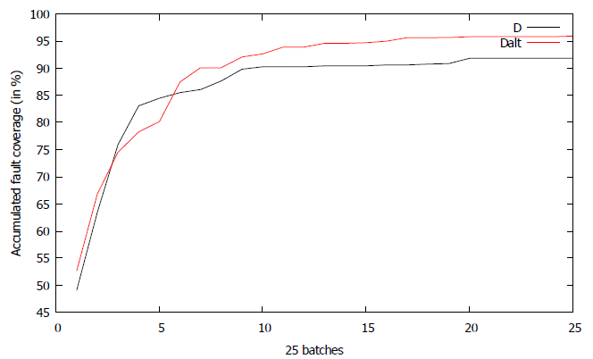

|  |  |
| --- | --- |
| Circuit: c880  Seed = 255  Batch size = 10  **NO FLIPPING**  TV_E vs TV | Circuit: c880  Seed = 255  Batch size = 10  **Alt-Flip**  TV_E_alt |
|  |  |